Windbelt Generator Built for $5 using VHS tape
BY DR DRASHCO · SEPTEMBER 14, 2013
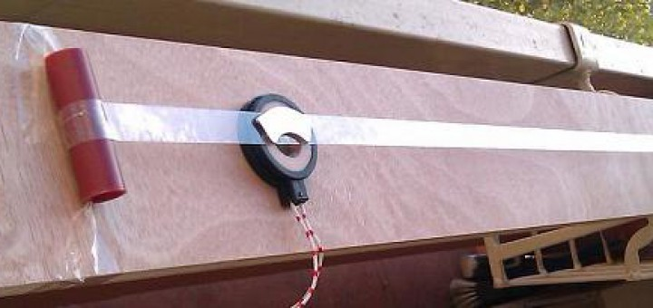
Micro windbelt generator is probably one of the cheapest and easiest DIY project ever. Even with its very limited power, small wind belt can be used in situations where conventional wind generator would normally fail to give any useful power output.
Windbelt is assembled using parts worth less than $5, which makes this windmill extremely cost effective! Price can go even lower in case you have an old VHS video tape, small fridge magnet and transformer coils.
On camping or sailing, windbelt generator can easily top up your portable FM radio batteries, iPad, iPhone, cell phone or even a small LED flashlight…
What is actually a “Windbelt” Wind Generator?
Wind belt is a vibrating membrane fitted with a pair of magnets that oscillates between copper wire coils. It works even in light breeze which makes it ideal small-scale wind generator. Device does not include any mechanical moving parts, it actually uses vibration to generate electricity. Conventional wind generators with rotating blades do not scale down so well due to high friction of moving parts and other mechanical components.
When it is windy outside, small wind-belt generator produces power sufficient for solar LED flashlight or battery charging. Practical application is virtually limitless, we have attached a standard USB connector (with voltage stabilized @ 5Volts) onto wind generator and made it possible to connect all modern mobile devices (iPod, iPad, MP3 player, smart phone…) which usually charge via USB port.
VHS Wind belt Generator – Construction Details
First, we have gathered all necessary parts for our micro wind generator. An old VHS videotape will be used as a membrane (Picture 1), two small neodymium magnets taken from from PC HDD (Picture 11) or from fridge-magnet souvenirs (Picture 2), and finally isolated copper wire coils – Picture 3. You need to fix the magnet(s) onto a (VHS) tape using glue. When a magnet moves beside a coil, electrical current is generated and flows through the wire, therefore windbelt starts to generate electricity.
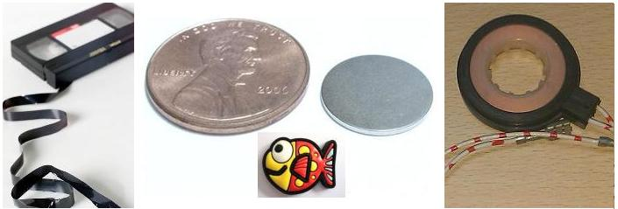
picture 1 picture 2 picture 3
If you want to use wind generator for LED lights, or to charge batteries there is no need for some hi-tech or complicated electronic circuit at the output. In case you want to charge batteries only, you can use very simple rectifier circuit (Picture 4). If you want to charge USB powered devices then you also need a small voltage regulator in addition to rectifier circuit (Pictures 5, 6 and 7), two neodymium magnets and two coils (connected in series) on the windbelt.
Electronic components should be soldered according to schematic diagrams shown below. Wires coming out of the coil(s) should be connected to rectifier diodes (Picture 7).
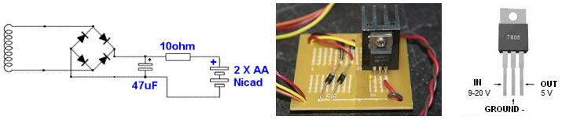
picture 4 picture 5 picture 6
WARNING! Diodes can be connected correctly only one way! Check out how to determine the polarity of a diode, it is important to locate the anode pin. Low power 1N5817 Schottky diodes are most convenient for windbelt generator.
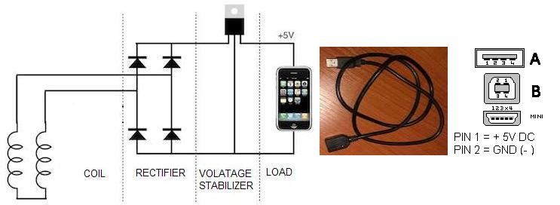
picture 7 – Windbelt electric schematic diagram picture 8 picture 9
We have bought USB extension cable (Picture 8) on e-bay, cut it in half and connected wires coming out of female USB connector directly to the output of windmill electronics (picture 7 – shown on the right side). USB extension cable has 4 wires, but we need only outer two, plus and minus 5V (Picture 9).
WARNING! Before connecting any USB device it is MANDATORY to check polarity and exact voltage (it has to be between 4.9 and 5.3 Volts) on micro-wind-generator USB connector using volt-meter!!!
Current prototype with 65cm long membrane (Picture 10) and strong neodymium magnet (Picture 11) can generate 40mW in a 10mph wind. Not a lot of power, however an easy to maintain array of wind belts could be assembled to generate as much power as it is required. Existing Windbelt prototype can generate electricity in winds over 4mph and at attack angles of up to 60 degrees. As the wind speed increases from 4 to 14 mph, the power output increases at a rate close to a cube of the increase in wind speed. At wind speed above 14 mph the power output becomes constant. One way to improve and stabilize the output of a wind belt generator across wider range of wind speed would be to dynamically increase the tension of the membrane as the wind speed increases…
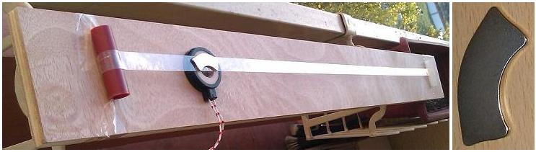
picture 10 picture 11
The Key Advantages of Windbelt over existing micro-wind turbine technology is not only the cost but simplicity and also the fact that it is good at taking power from turbulent wind flows, i.e. in a built up domestic setting, and it is also very quiet in operation. Unlike PV solar panels, wind turbine generators do not scale down so well. While large wind turbines can generate huge quantities of electricity very efficiently and relatively cheaply, as the size of the wind turbine is reduced, efficiency reduces and cost per generated watt jumps quite enormously.
Wind belt is an ultra efficient and mechanically very simple wind generator alternative. Its cheap components can be bought almost anywhere in the world. Windbelt is originally an innovation of mr. Shawn Frayne. He constructed this simple device with a taut Mylar membrane fitted with a pair of Neodymium magnets that oscillate in and out of coils because of the mechanical resonance of the membrane with wind blowing across it. At wind speeds of 10 mph, the membrane oscillates at 90-100hz – i.e. the magnets move in and out of the coils 90-100 times per second. Unlike a photovoltaic solar panel or conventional wind turbine generator, Wind-belt can be constructed, repaired and maintained by just about anybody.
Larger home made versions of the wind belt are possible, but usually the problem of noise emerges. In any case, we have to be aware that power potential of these kinds of low-tech energy sources is quite modest. That is why they can be used only to supply power to devices with a very low energy consumption or to be used in remote areas where we do not have an alternative. If wind-belt DIY project cannot satisfy your power hungry devices, please take a look at our mini wind generator DIY project. As a generator we have used stepper motor scraped from an old 5.25 inch floppy drive…

